Power Amplifier Selection

Rogelio Juarez

SlugSat 2018

Linear Transponder

# Introduction

RF Power Amplifiers are typically used as the final gain stage within the Transmitter chain in a wide variety of applications, such as Wireless Communications. The design of the Power Amplifier is one of the most important in the transceiver architecture, since the linearity of the system is dominated by the last stage. Our Linear Transponder will receive either CW (continuous wave) or SSB (single sideband) signals; moreover, the design of the PA will dictate whether the message encoded on the transmitted signal will be successfully received on Earth’s ground station.

# Criteria for Success

When determining a proper PA (power amplifier) for our application, one must consider the following: linearity, efficiency, gain, power consumption, output power compression point, temperature rating, rated frequency range, and signal modulation type. The following criteria have interdependencies and each trade-off must be justified.

## Expected PA Performance

Based on our Linear Transponder System Level Specification, the PA will be designed to have a gain of 30 dB, operate within 29 MHz, have industrial temperature rating of at least -40 ℃ to 85 ℃, provide high linearity based on CW and SSB communication, current consumption no greater than 1 Watt, and an output P1dB greater than +21 dBm.

### Gain

Based on our LT Link Budget, our receive power range is -66 dBm to -92 dBm, and our target transmit power is +21 dBm. Not taking into account the gain provided by the VGA from the AGC, the gain up to the PA is 56 dB (LNA, Up/downconversion mixers). Assuming we receive at the highest power level, which is -66 dBm, the signal level before the PA will be -10 dBm. Since we are targeting +21 dBm at the output of the PA:

→ GaindB = Pout,dBm - Pin, dBm

→ GaindB = 21 dBm - (-10 dBm)

→ **GaindB = 31 dB**

### Frequency Range

Our Transponder will operate on the 15/10 [m] HF band with a bandwidth of 30 kHz, where the uplink frequency is 21.385 - 21.415 MHz and the downlink frequency is 29.300 - 29.330 MHz. Since our PA used for the downlink frequency, its performance must be rated to operate within 29 MHz.

→ **FPA = 29 MHz**

### Temperature Rating

To ensure proper functionality in space environment, all parts should be certified for the industrial temperature range of -40**°**C to 85**°**C.

→ **Operating Temperature Range = -40°C to 85°C**

### Linearity and Efficiency

For SSB communication, we must use a very linear power amplifier, since the signal’s message has been modulated onto the carrier’s amplitude. This type of waveform is called a variable-envelope signal, and a quantitative measure of the signal’s envelope variations is the PAPR (Peak-to-Average-Ratio). A signal with high PAPR will have large variations in its amplitude, while one with low PAPR will tend to have a constant envelope. SSB waveforms will have high PAPR, and consequently will need more power backoff from the PA’s input compression point. Power Amplifiers that are designed to operate below the P1dB point, and provide a constant gain are classified as Linear PA’s. Using a nonlinear amplifier will distort our transmitted signal, therefore distorting our message to the ground station.

The Power Amplifier’s Efficiency is defined as “a measure of its ability to convert DC power of the supply into the signal power delivered to the load” (cite this).

→ $η$ = Signal power delivered to load/DC power Supplied to output circuit

There are different PA classes that, depending on the class, define its linearity and efficiency. These classes vary from Class A to Class F, where Class A has the highest linearity, but lowest efficiency. Class F amplifiers are highly nonlinear, but provide high efficiency. For our Transponder signal communication, we must provide high linearity, but at the same time wish for decent efficiency. Therefore, it behooves the designer to research Class-A, Class-B, and Class-AB power amplifiers. It is important to note that the type of bias applied to the RF power transistor determines the class. When determining the bias, it is helpful to refer to load-line theory, which determines “the maximum power that a given transistor can deliver is determined by the power supply voltage and the maximum current of the transistor” (cite this).

#### Class-A PA

For Class-A power amplifiers, the quiescent point is defined as Imax/2, and Vpos:

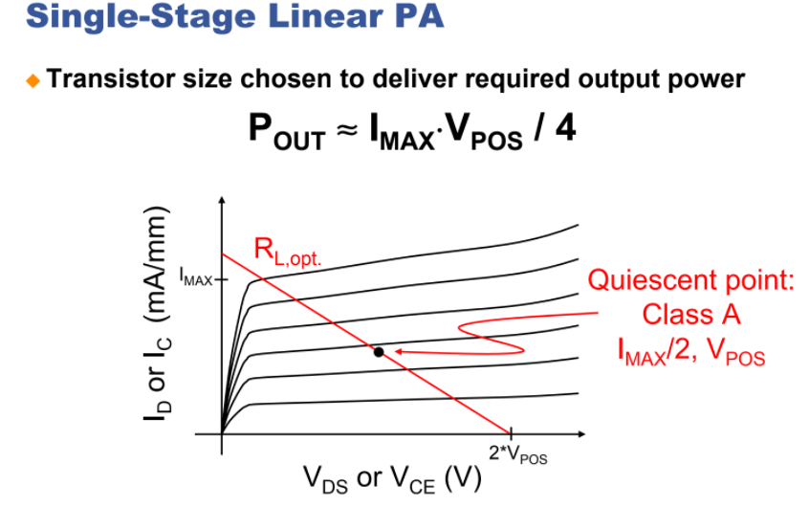

**Figure (XXX):** cite this

Consequently, this PA has constant output current flow, meaning it conducts for the full cycle of the input signal. This allows the output signal from the PA to very closely follow the input signal to the PA, which classifies it as highly linear. However, due to it always conducting, it has only 50% efficiency:

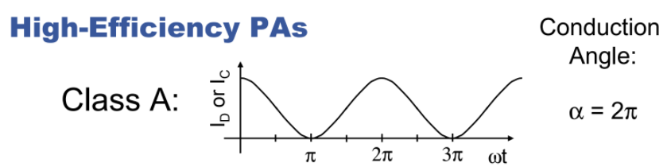

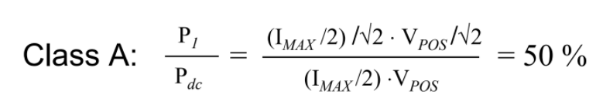

**Figure (XXX):** cite this

#### Class-B PA

These PA’s offer higher efficiency, since the transistor only conducts for half of the time, thus the conduction angle is approximately 180°:

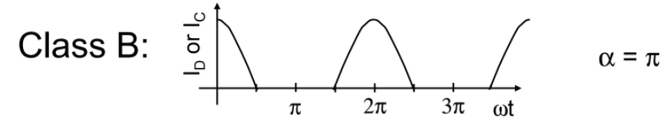

**Figure (xxx):** cite this

However, since only half of the input signal will be present at the output, there will be significant distortion.

#### Class-AB PA

This amplifier offers linearity and efficiency both in between Class-A and Class-B PA’s. It has a conduction angle in between 180°-360° and an efficiency between 50% and 78.5% (cite this).

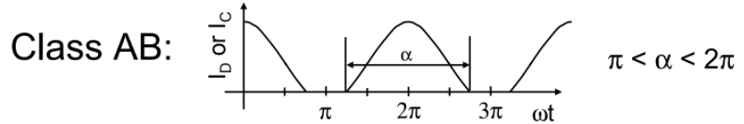

**Figure (xxx):** cite this

The increase of efficiency from Class-A is a trade-off from the guaranteed linearity. According to the article “RF Power Amplifiers” by Iulian Rosu, “Class-AB is not a linear amplifier; a signal with an amplitude-modulated envelope will be distorted significantly at this peak power level. This reason is in fact that in Class-AB operation the conduction angle is a function of drive level”. Therefore, careful consideration must be taken place if this class were to be used for SSB communication.

### Current consumption

The power allocated for the Linear Transponder as a whole, according to the Power Team’s Power Budget, is a maximum of 1.5 W. Besides the PA, the rest of the Linear Transponder will ideally consume around 0.5 to 1W of power (cite LT System Spec document). This leaves the PA a maximum of 1W power consumption:

→ **PPA,max = 1W**

### Output P1dB

Since we are dealing with SSB communication and therefore need a linear PA, we must not exceed both the input/output power compression point of our amplifier:

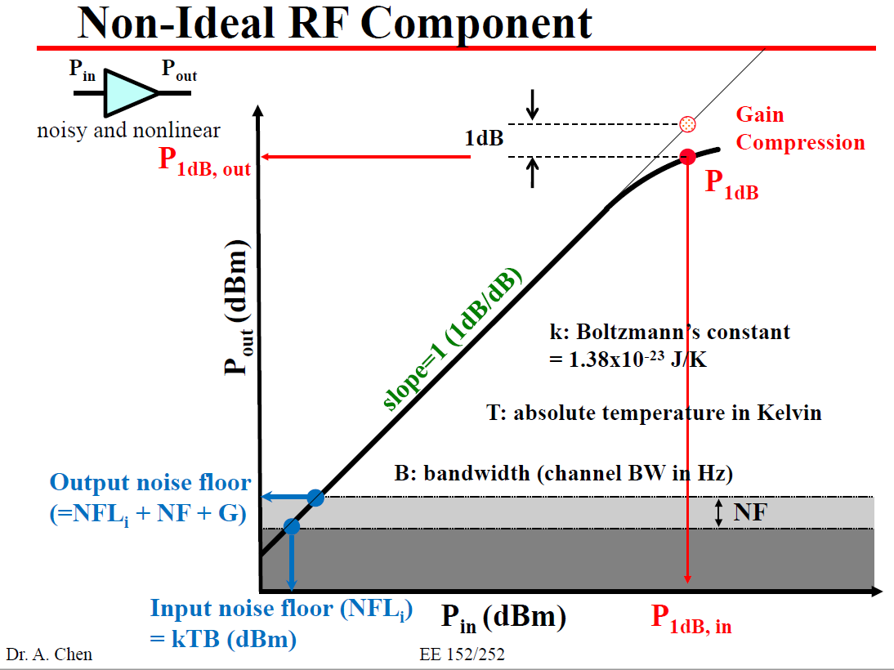

**Figure xxx:** cite this

Since we want to transmit a signal with a power of +21 dBm, our amplifier must have an output compression point of at least +21 dBm. If our PA has a gain of 30 dB, then our input compression point must be less than -9 dBm:

→ **OP1dB > 21 dBm**

→ **IP1dB < -9 dBm**

## Power Amplifier Candidates

|  |  |  |  |  |  |  |  |  |  |  |
| --- | --- | --- | --- | --- | --- | --- | --- | --- | --- | --- |
| Power Amplifier | Mfr. | Frequency Range | Gain | OP1dB | Linearity | ŋ | Supply Voltage | Supply Current | Power | Operating  Temp. |
| SXB2089Z | RFMD | 5MHz - 2500MHz | 25dB | 24 dBm | High | N/A | 8V | 135 mA | 1.08W | -40 t0 85 ℃ |
| CGR-0118Z(CATV) | RFMD | 5 MHZ -65 MHz | 25.4 dB | 26.5 dBm | N/A | N/A | 8V | 130 mA | 1.04 W | -40 to 150℃ |
| RF3827 | RFMD | 5 Mhz - 1500 MHz | ≅19 dB | 23 dBm | High | N/A | 8V | 100 mA | 800 mW | -40 to 85℃ |
| TQP3M9019 | Qorvo | 20-4000MHz | 22 dB | 22 dBm | High | N/A | 5V | 125 mA | 625 mW | -65 to 150℃ |
| AFIC901N | *F.S | 1.8 - 1000MHz | 30 dB | 30.6 dBm | N/A | 62.1% | 7.5V | IDQ1 = 8mA  IDQ2 = 24mA |  | -65 to 150℃ |

*Freescale Semiconductor

### SXB2089Z

This PA is a top candidate due to its gain, high linearity, frequency range spec, output P1dB point, and power consumption. However, after review with Professor Peterson, further inquiries need to be made about the PA efficiency, definition of thermal resistance, component type for ESD diodes used, any technical data in the 30 MHz range, radiation testing documentation, and why the supply voltage is specified at 8V but the maximum voltage for the device is 6V.

After discussion with David Oliver, Qorvo’s Head Applications Engineer, I learned that there was no radiation testing done, this part is dual transistor (though not Darlington) design, so the series resistor is likely needed to emulate a current source, and he provided a tune and data for 20-50 MHz, which is located in the [drive](https://drive.google.com/drive/u/0/folders/1DpVoR4TNL96iu_6nlqE9kYSj9XpSZzD8):

A major concern for this amplifier is that it draws 135 mA of static current, since it is classified as Class-A. Class-A amplifiers have a maximum efficiency of 50%, and have constant output current flow.

<https://drive.google.com/drive/folders/1_lY_uIQ3X1faWF13e4d7qJUT5A20ar9M>

### CGR-0118Z

At first this amplifier seemed like a good fit based on meeting the minimum criteria, but its availability for purchase is scarce. I have only found it online at Mouser, where it is only sold in full reel, and only available to order in multiples of 2500. Each IC costs $15, so this totals to a minimum of $38,000, which is not going to happen. This amplifier is also a CATV amplifier, which is used for Cable TV, and I am unsure if this is a suitable fit for our needs.

After discussion with Professor Peterson, an amplifier used for Cable TV is relevant if it meets our criteria. Professor Peterson also mentioned that it is possible to receive samples of the IC from the manufacturer, instead of purchasing a full reel.

However, this amplifier also draws 130 mA of static current, and does not meet our needs in terms of efficiency.

<https://www.mouser.com/ds/2/412/gr_0118z_data_sheet-781281.pdf>

### RF3827

This amplifier offers 10 dB lower gain than the minimum requirement, but only consumes 800 mW of power, which is very desirable. The main concern for this amplifier is that it is mainly used as an LNA/Driver amplifier, and in the datasheet, its output P1dB is rated for 23 dBm, which is close to our desired 21 dBm transmit signal power. Ideally I would like more headroom for our output P1dB point, and I am unsure if it’s a good idea to move forward with this part. This part is available on Qorvo for around $5.

Due to it being Class-A, it’s poor efficiency is a major concern regarding selection as PA.

<https://drive.google.com/drive/folders/1_lY_uIQ3X1faWF13e4d7qJUT5A20ar9M>

### TQP3M9019

Although this amplifier consumes the least amount of power amongst the other candidates, its output P1dB point is 22 dBm, which is even closer to our +21 dBm transmit power. This P1dB also varies across temperature, where it drops to around 21 dBm at 85℃. It also states that it is a high linearity LNA Gain Block, and I am unsure if we should use this, since technically we need a PA, not another LNA in the transmit chain.

Due to it being Class-A, it’s poor efficiency is a major concern regarding selection as PA.

<https://www.mouser.com/ds/2/412/TQP3M9019-894309.pdf>

### AFIC901N

Although this amplifier fits our minimum requirements and provides the highest gain of all the candidates, after review with Professor Peterson this particular amplifier is mainly used for FM communications, typically operating at VHF/UHF of 136 - 174 MHz, and 350 - 520 MHz, and was ruled out. It is considered a Class-AB amplifier since its efficiency is between 50-78.5%, which does not meet our linearity requirement for SSB communication.

<https://www.nxp.com/docs/en/data-sheet/AFIC901N.pdf>